**This exercise is for front end developer applying to cermati.com**

**Please do not share this to other people.**

We want you to write an html page. The html page can be about anything. *What’s important is you need to write very long random text to make it so you need to scroll down to see the whole page*. The point is the html page need to be long so you need to scroll.

What we want you to build are 2 components in the html page:

1. A banner on the top of the page that asks for an email.
2. A slider that pops up on the bottom left when the user scroll to 50% of the page.

**The buttons don’t have to work (it doesn’t have to send a POST request)**. You just have to care about the CSS styling and the way it behaves when we resize the html page. Please make sure that the style is the same. For example Banner has center align, whereas the slider has left alignment. The font matters too, if there are 2 different font, then use 2 different font. If there is an X icon, then use X icon. **So try to follow as closely as possible to the mockup below.**

Here is what the banner and the slider look like on **desktop** screen:

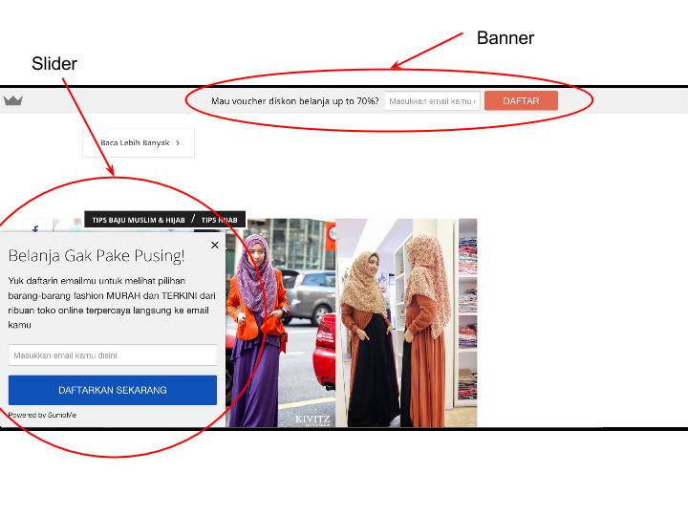Here is what the banner and slider looks like in **mobile** screen

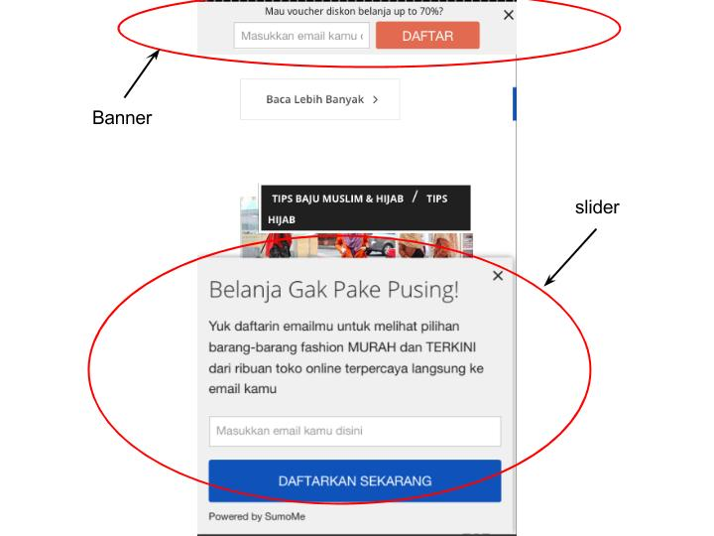

The banner always follows the user when the user scroll down or up.

But the slider only shows up when the user has scrolled down about 50% of the page. And the banner also follows the user when the user scroll down or up. So the banner is **not** “modal”.

The only difference between desktop and mobile is the slider takes about half the screen on mobile while on desktop, the slider takes only the left bottom part of the screen. The size of the slider is fixed on mobile but on desktop the size of the slider is 50% of the screen’s width until it shrink to mobile where the size becomes fixed. For more precise detail of the size, you can go to [www.cermati.com](http://www.cermati.com) on incognito mode and see how our slider behaves.

So we want you to build the same thing.

**The specification (please follow these specs carefully):**

1. We need to have a banner on the top of the page the follows the user when the user scroll up/down
2. We need to have a slider that only shows up when the user has scrolled half the page. The slider needs to “slide up” and not just suddenly appear.
3. We want the html page to be “responsive” meaning if the user looks the screen on a small mobile device, he will see the “mobile” version. If the user uses large computer screen, he will see the “desktop” version. For how the mobile/desktop transition work, you should check www.cermati.com
4. We want the slider to ***remember*** if the user closes the the slider the first time. it will not show up again for the user for at least 10 minutes.
5. **We don’t want you to use 3rd party library like bootstrap or jquery**. Just write your own javascript and css.
6. We want you to follow the exact color scheme, exact text/wording, exact style of the banner and slider like we show you on the picture above. So to make it more clear, the button for the banner must be orange. The button for the slider should be blue. The text for the banner should be “*Mau voucher belanja up to 70%?*” “*Masukkan email kamu*” “*Daftar*”. The text for the slider should also be the same as the pictures.
7. The page needs to work on multiple browsers. But for the purpose of this exercise, please make sure the html page works on **chrome, firefox and android browser.**
8. The color grey, blue and orange are not specified. So you can use whatever blue/gray/orange

You may use google, stack overflow, and any other online resources to do this task. **Please follow the spec carefully.**

Good luck!